**PRACTICAL - 7**

**AIM: Displaying data from Multiple Tables (join)**

**QUERIES:**

**(1) Give details of customers ANIL.**

SELECT CUSTOMERS.CNAME, CUSTOMERS.CITY, BORROW.LOANNO, BORROW.BNAME, BORROW.AMOUNT FROM CUSTOMERS INNER JOIN BORROW ON CUSTOMERS.CNAME=BORROW.CNAME WHERE CUSTOMERS.CNAME='ANIL';



**(2) Give name of customer who are borrowers and depositors and having living city nagpur**

SELECT DEPOSIT1.CNAME FROM DEPOSIT1, BORROW WHERE DEPOSIT1.CNAME=BORROW.CNAME AND DEPOSIT1.BNAME IN('VRCE','AJNI','DHARMPETH');

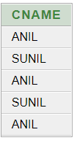

**(3) Give city as their city name of customers having same living branch.**

SELECT CNAME, CUSTOMERS.CITY FROM CUSTOMERS, BRANCH WHERE CUSTOMERS.CITY=BRANCH.CITY;



**(4) Write a query to display the last name, department number, and department name for all employees.**

SELECT EMP_NAME, DEPT_NO,DEPT_NAME FROM EMPLOYEE;

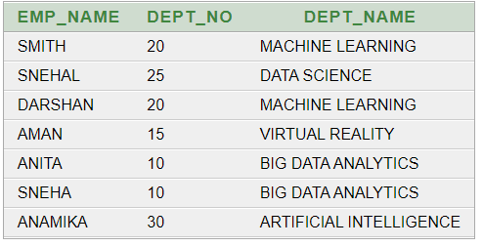

**(5) Create a unique listing of all jobs that are in department 30. Include the location of the department in the output**

SELECT DISTINCT(DEPT_NAME), JOB_ID,LOCATION FROM EMPLOYEE WHERE DEPT_NO='30';

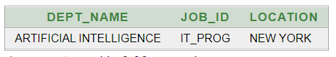

**(6) Write a query to display the employee name, department number, and department name for all employees who work in NEW YORK.**

SELECT EMP_NAME,DEPT_NO, DEPT_NAME FROM EMPLOYEE WHERE LOCATION='NEW YORK';

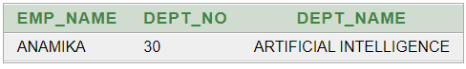

**(7) Display the employee last name and employee number along with their manager’s last name and manager number. Label the columns Employee, Emp#, Manager, and Mgr#, respectively.**

SELECT A.EMP_NAME AS "EMPLOYEE", A.EMP_NO AS "EMP#", B.EMP_NAME AS "MANAGER", B.EMP_NO AS "MGR#" FROM EMPLOYEE A, EMPLOYEE B WHERE B.EMP_NO=A.MANAGER_ID;

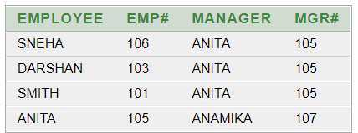

**(8) Create a query to display the name and hire date of any employee hired after employee “smith”.**

SELECT EMP_NAME, HIREDATE FROM EMPLOYEE WHERE HIREDATE>(SELECT HIREDATE FROM EMPLOYEE WHERE EMP_NAME='SMITH');

